Aims
This is a revision activity for Chapter 1. Work through each task to help you revise key concepts.
Task 1: Nutrients
Completing this table will help you to explain the nutrients the human body needs.
Name of nutrient | We need this nutrient for: | If we don’t get enough of  this nutrient then:
carbohydrates
lipids
proteins
vitamins
minerals
water
fibre
Pick one of the nutrients from the table. In the space below, write an explanation of why we need that nutrient in the body. The headings in the table will help you. You need to write in full sentences.

Task 2: Underweight and overweight
Link the risks on the left to the person profile on the right.
Increased risk of stroke
Lack of energy |  | Someone who is obese
Rickets
Poor immune system
Increased risk of diabetes |  | Someone who is underweight
Increased risk of some cancers
Use your answers above to describe the health problems someone who is underweight may face.

Task 3
Different people have different energy requirements. Look at the information given on the two people below. They are the same height and the same weight.
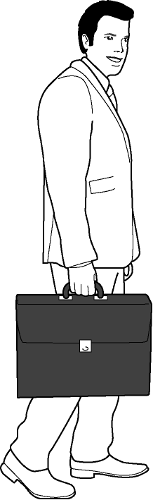
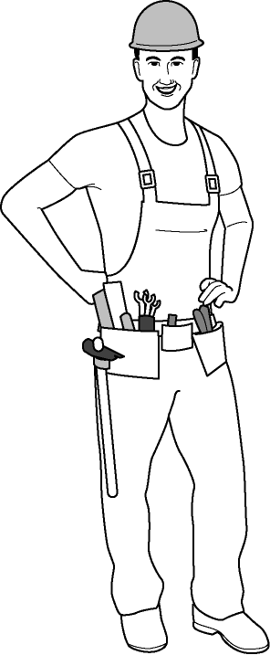
Office worker |  |  | Roofer
Energy requirement for a typical day | 9660 KJ |  | Energy requirement for a typical day | 14 020 KJ
Extra activities  (e.g. exercise) | 400 KJ |  | Extra activities  (e.g. exercise) | 400 KJ
Now read the information on these two diets. Which diet would the roofer need to maintain a healthy weight? Circle your answer.
Diet 1 A balanced diet that provides 14420 KJ.
Diet 2 A balanced diet that provides 10060 KJ.

Task 4: The process of digestion
The table below shows the main structures of the digestive system. They are in the correct order to show the process of digestion. Write a description for what happens in each part of the digestive system.
Try to use these key words:
feces nutrients saliva bloodstream
Structure | Description
mouth
gullet
stomach
small intestine
large intestine
rectum
anus
Adaptations of the small intestine
Look at this picture of the villi in the small intestine. Villi help to increase surface area. Why do you think the small intestine needs a large surface area? Look back at your description above to help you.
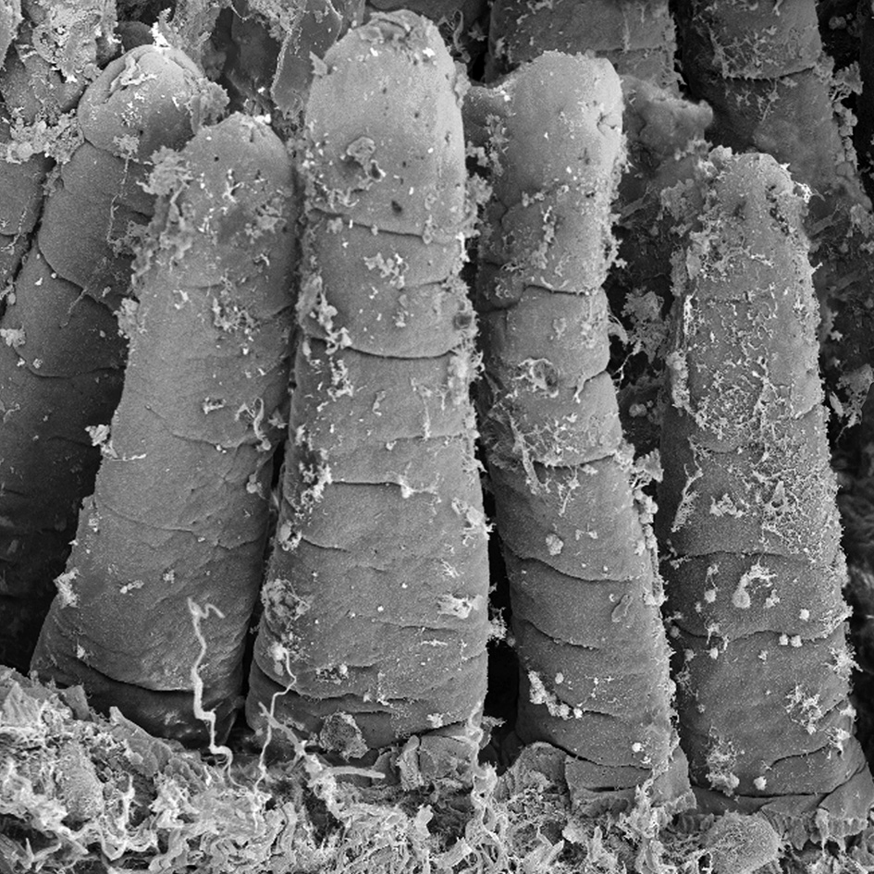

Task 5: Enzymes and bacteria
The diagram shows how enzymes are involved in digestion. Use these key words to label the diagram.
lipid molecules lipase fatty acid and glycerol molecules digestion

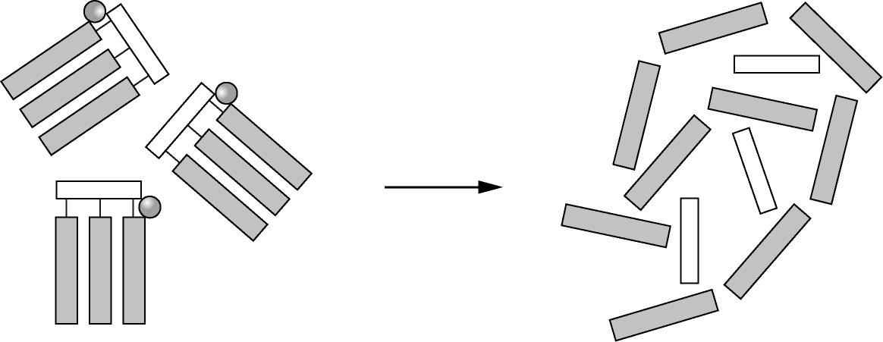

Bacteria are also involved in digestion. Complete the paragraph below to describe the role of bacteria.
Your contains bacteria. These bacteria live on
the in your diet. They make important vitamins such
as . These vitamins are then absorbed into your body and
keep you healthy.
Task 6: Health problems
You are a health advisor working for a problem page of a magazine. It is your job to write responses to letters that are related to health. Read the letters below, and write a response. In your response you should consider:
- the type of person is writing the letter
- the effects that need to be considered for that person’s health.

Dear Doctor,
I would like to start trying to conceive a baby. I’m not sure whether I should be drinking wine or not. Please could you advise on whether I can drink wine when am trying for a baby, and also when I’m pregnant? I also smoke five cigarettes a day. Is this safe?
Thanks,
Elizabeth Western

Dear Doctor,
Some of my friends have been taking a drug called cocaine. It started just at parties, but now they seem to be taking it all the time. Should I be worried?
Thanks,
Allen Holland

Dear Doctor,
My dad smokes 20 cigarettes a day. I’m worried that it’s harming his health. What can I say to him to convince him to cut down?
Thanks,
Ali Jafri

