Year 7 Knowledge Booklet
The British Empire

Wise Words
Viceroy Aborigine
Cartridge Australia
Sepoy Sikh
Mutiny Passive Resistance
Empress of India

Knowledge Organiser

What is an Empire?
An 'empire' is a group of countries ruled over by a single monarch or ruling power. An empire doesn't need an 'emperor'. The British Empire comprised Britain, the 'mother country', and the colonies, countries ruled to some degree by and from Britain.
The British began to establish overseas colonies in the 16th century. By 1783 Britain had a large empire, with colonies in America and the West Indies. This 'first British Empire' came to end after the American Revolution.
However, in the 19th century, the British built a second worldwide empire, based on British sea-power, India, and huge conquests in Africa.

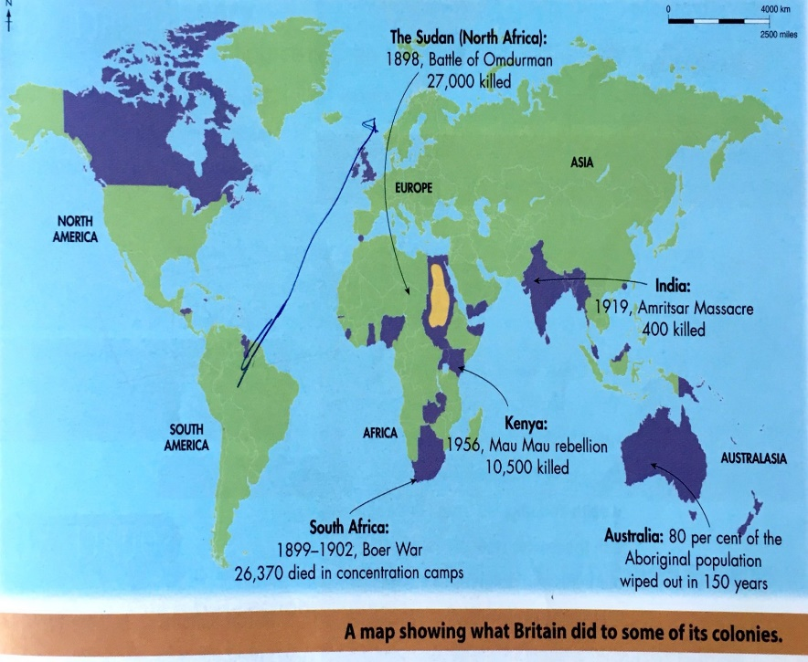
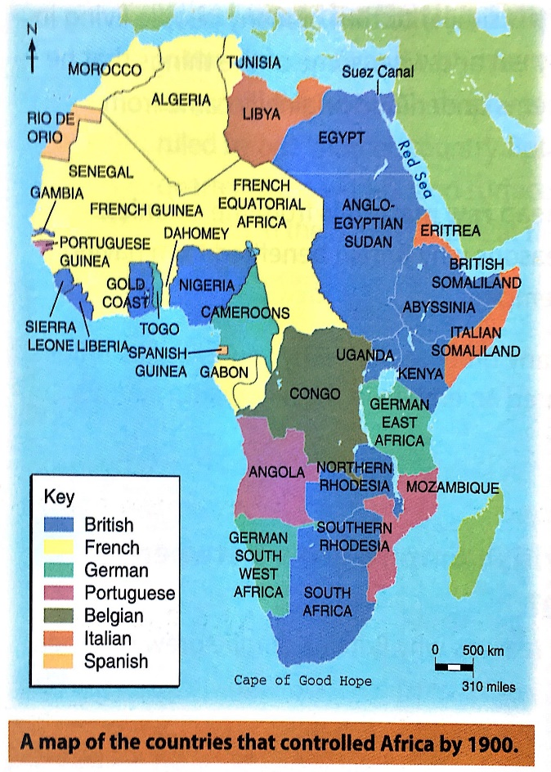
Knowledge Box
Britain wanted an Empire…
- To get valuable raw materials
- So Britain could sell goods to the colonies and make money
- To become a more powerful country
- Because Britain thought it was the right thing to do
So how did Britain get its empire?
- War: If Britain won a war against another country. Britain could often take over any land the other country owned around the world. For example when Britain won a long war against France, land previously conquered by France became part of the British Empire. That is how Canada and islands in the West Indies such as Tobago and St Lucia became part of the British Empire
- Settlers: Sometimes British people would go to another part of the world and start to live there. That is how large parts of the east coast of America became part of the British Empire.
- Discovery: Occasionally explorers would find land and just claim it for Britain. That happened in 1770 when Captain James Cook sailed to Australia. The tribes that already lived there were ignored and Australia became art of the British Empire.
- Trade: When British companies went to trade in some places, they slowly took over large areas. The government sometimes sent soldiers to help companies. That happened in India and parts of Africa.
India was known as the ‘jewel in the crown’ and came under British rule in 1858
In the 1880s Britain expanded its territory in Africa as part of the ‘Scramble for Africa’

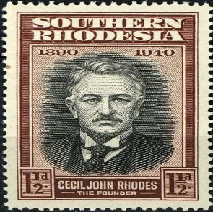
Cecil Rhodes played a key role in the ‘Scramble for Africa’ Below are some key facts about Rhodes. Colour code them as

Reasons he was important at the time ie the impact he had during his lifetime |  | Reasons he was significant in later periods ie after his death
Cecil Rhodes came to Cape Colony (South Africa) at the age of 17. He became a powerful figure in diamond mining in southern Africa. | In May 1895 Rhodes founded Rhodesia. Rhodesia was rule by a white supremacist government between 1965 and 1980 which gave no voting rights to black Africans | Rhodes’ prevention of black Africans voting helped lead to the racist apartheid system in South Africa that lasted until 1994 | Rhodes demand of expanding British territory. He wanted to build a railway from the Cape of southern Africa to Cairo in Egypt
In 1896 Rhodes lost his position of Prime Minister after leading an attack on nearby Boer territory | The De Beers diamond company, set up by Cecil Rhodes in 1888 is still of the most famous diamond companies in the world | In 2015 protests were held demanding a statue of Rhodes be pulled down at Oxford University | During his time as Prime Minister of Cape Colony (1890-1896) Rhodes prevented black Africans from voting.

Case study india
The Indian Mutiny 1857
British influence in India began mainly because of the British East India Company and its desire to look after its trading interests in the area.
The company set up its own army. It recruited Indian troops and put British officers in charge of them. 96% of the 300,000 strong British army in India were Indians.
Many Indians were uneasy about British control- especially when Christian missionaries started to spread Christianity into the continent.
This unease came to a head in 1857 when the British government introduced a new type of rifle into the Indian army. The Indian soldiers were told to grease the cartridge of the rifle with cow and pig fat. This was extremely offensive to Hindus and Muslims. To Hindus the cow is sacred and Muslims do not use or eat any produces made from pig.
The British realised their mistake and replaced the animal fats with vegetable oils. But the damage had already been done. In May 1857, an Indian soldier shot his British officer and the violence quickly spread.
This mutiny was a serious threat to British power in India and an opportunity to gain freedom from British influence.

India was the largest and richest of all the countries in the British Empire. In the 1850s a viceroy, appointed by the British in London, was put directly in charge of the country and ran it on behalf of Queen Victoria. The Queen even gave herself an extra title and started calling herself ‘Empress of India’
The Salt March 1930
By the 1930s many Indians were beginning to demand independence from British rule and wanted to drive the British out of India.
The leader of the campaign was Gandhi.
Gandhi tried to achieve independence by using the non violent method of passive resistance. The most famous example of this was the Salt March of 1930.
Indians were made to buy salt at high prices from British companies. It would have been cheaper if they had been allowed to make salt themselves. In March 1930, Gandhi began a 200 mile march to the sea. He was joined by thousands of followers along the way. When he got there he simply bent down and picked up a chunk of sea salt from the shore.
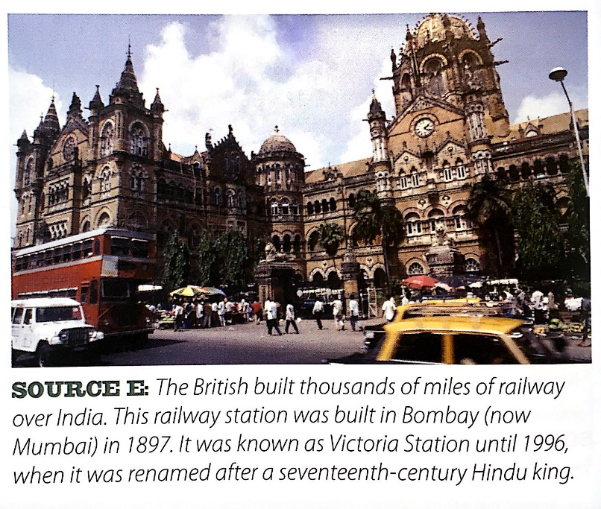
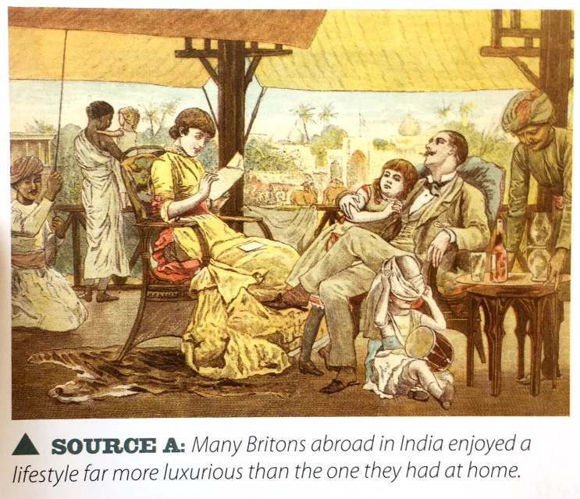

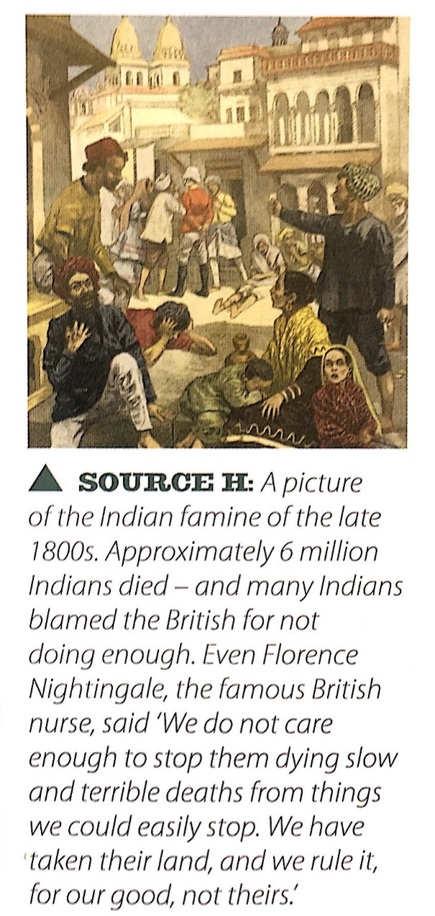
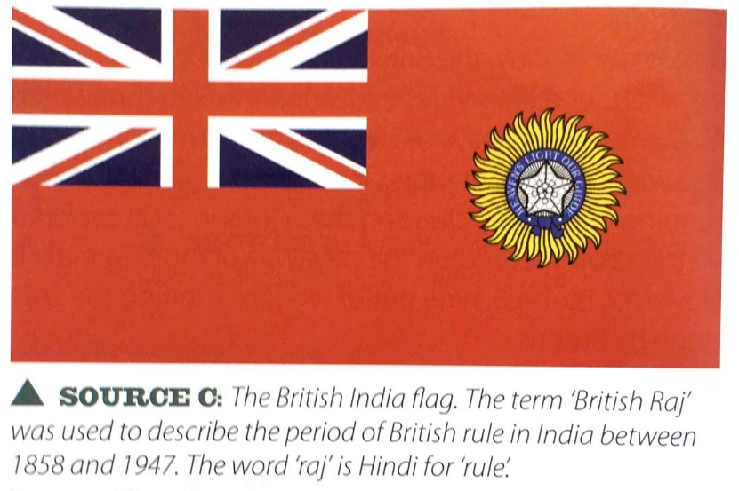

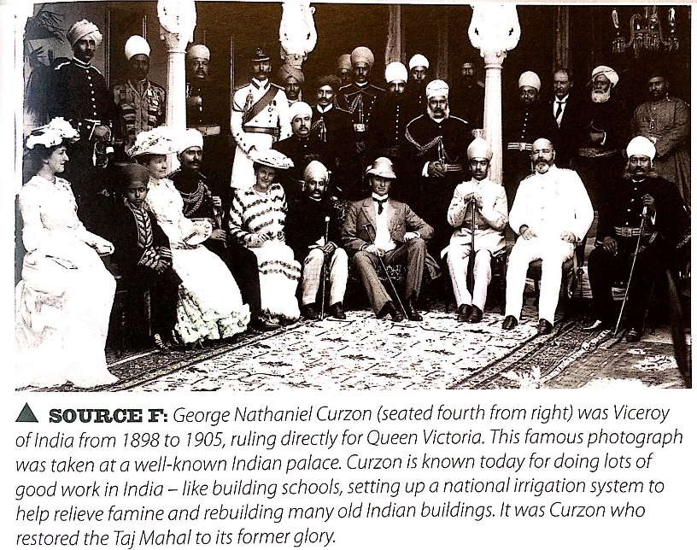

Case study Australia
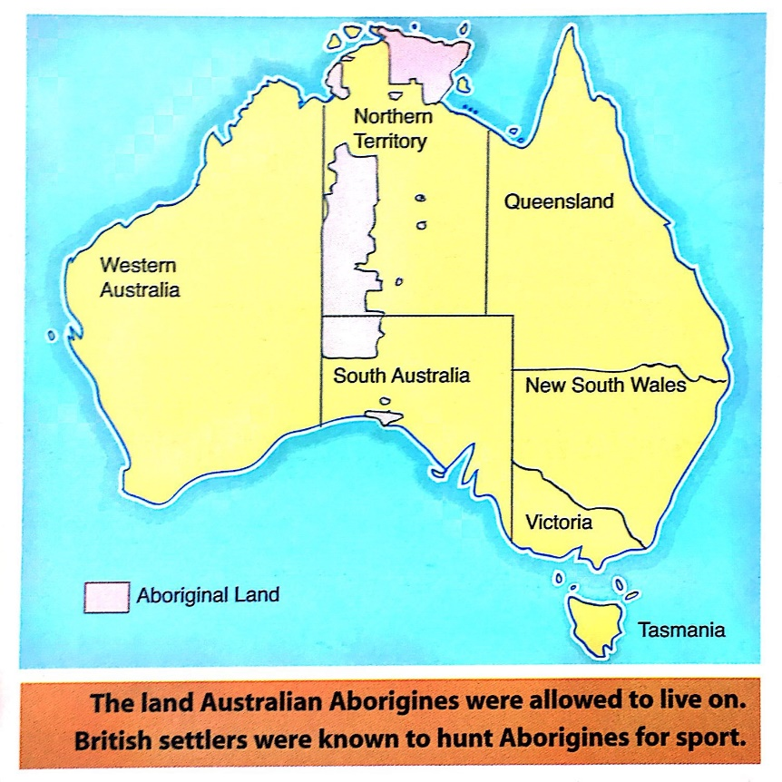
Britain's first contact with Australia came with Captain Cook's voyage in the ship Endeavour. He landed in Australia in 1770 and claimed it as a British territory. The process of colonisation began in 1788. A fleet of 11 ships, containing 736 convicts, some British troops and a governor set up the first colony of New South Wales.
It was an incredibly risky idea. The government had very little idea about what the colonists would find. They did not even know much about the climate. However, the risks paid off. By colonising Australia Britain gained an important base for its ships in the Pacific Ocean. It also gained an important resource in terms of being somewhere to send convicts. Until the American Revolution Britain could send convicts to the Thirteen Colonies. However, this ended when the Americans declared their independence. Transportation was an important part of the legal system in Britain, and by the 1780s there were large numbers of convicts in Britain who had been sentenced to transportation and had nowhere to go! New South Wales presented the ideal opportunity for Britain to get rid of its convicts and in the next 60 years about 160,000 were transported to Australia.
Thousands of other British settlers also migrated to Australia. They were attracted by the easily available land (which led to conflict with the aborigines). They could make a living raising sheep or by catching seals and whales. In 1826 settlers began colonising Western Australia. The colony of South Australia was set up in 1834. A whole new wave of migration was sparked off in the 1850s by the discovery of gold and the white population of Australia rose by around half a million in 10 years (while the Aboriginal population decreased).
Australian Aborigines
Aboriginal peoples lived in Australia for thousands of years before Europeans arrived. They suffered greatly as a result of the arrival of the British in Australia. When Captain Cook visited in the late 1700s it is estimated that there were about 750,000 Aborigines. By the 1920s this number had fallen by around 90%. There were violent clashes between the Aborigines and the settlers in the early years. However, most deaths were caused by diseases that Europeans brought to Australia, and the gradual takeover of Aboriginal lands for farms and settlements. British farming methods, like the use of wire fences, disrupted the traditional Australian way of life and led to further violence between British settlers and Aborigines. The introduction of sheep and rabbits devastated their environment, their food sources and hunting grounds. Settlers often killed Aborigines who trespassed onto 'their' land. Many Aborigines moved to the towns to try and make a living. Here they suffered discrimination and disease, with alcoholism being a particular problem. British governors and officials in Australia were generally less harsh towards the Aborigines than the settlers of British descent. After the British handed over direct rule to Australia in 1901, the treatment of Aboriginal peoples did not improve.

Knowledge Questions on the empire
- What is an Empire?
- Why did Britain want an Empire?
- How did Britain get their Empire? What were the four methods?
- Which country was the Jewel in the Crown?
- What was the scramble for Africa?
- What was the size of the British Empire?
- How many people from the Earth’s population lived in the Empire?
- What year was the Indian Mutiny?
- Why were Indians upset with the British?
- What was a viceroy?
- Who was the Empress of India?
- Who was the British Raj?
- What year was the Salt March?
- Who was Ghandi?
- Who discovered Australia and in what year?
- Which group of people did Britain send there?
- Who were the Native people who lived in Australia?
- What valuable resource was found in the 1850s?
- What impact did the British have on the native people?
- In what year was direct rule handed over to Australia?

