YEAR 7 KNOWLEDGE BOOKLET SUMMER TERM 2018
LA VILLE ET LE TEMPS

Describing my town:
Ma ville est jolie My city is pretty
Ma ville est moche My city is ugly
Ma ville est belle My city is beautiful
Ma ville est moderne My city is modern
Ma ville est vieille My city is old
Ma ville est bruyant My city is noisy
Ma ville est calme My city is quiet
Ma ville est grande My city is big
Ma ville est petite My city is small

Translate into French:
- My city is very big
- My city is quite noisy
- My city is modern but quite small
- My city is beautiful or old

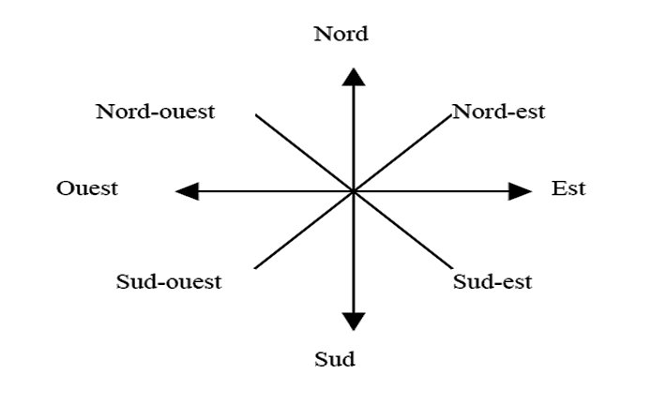

Le temps The weather
Il fait beau it is nice
Il fait chaud it is hot
Il fait froid it is cold
Il y a du soleil it is sunny
Il neige it is snowing
Il fait mauvais it is bad weather
Il y a du brouillard it is foggy
Il y a des nuages it is cloudy
Il pleut it is raining
Il y a des orages it is stormy
Il y a du vent it is windy
Les saisons seasons
En été In summer
En hiver In winter
En automne In autumn
Aux printemps In spring
Les fêtes Feast Days
À Noël At Christmas
À Paques At Easter
Pendant les vacances During the holidays

Write in French the weather condition:
_____________________________

_____________________________
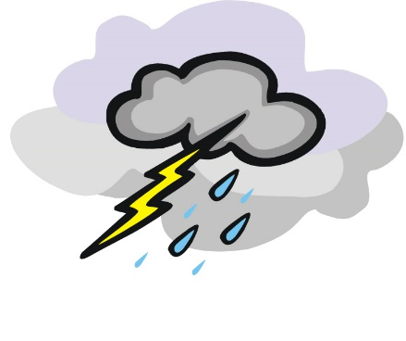 _____________________________

_____________________________

__________________________________

In French write the season/Feast Day and weather:

 





