In this half term you will be regularly tested on these key skills:

Skill | Example | Support
Divide in a given ratio | Divide £120 in the ratio 1 : 5 | Hegartymaths  Clip 332
Simplify a ratio involving mixed units | Simplify the ratio  300 g : 2 kg | Hegartymaths  Clip 329
Find the volume of a cuboid | Find the volume of this cuboid  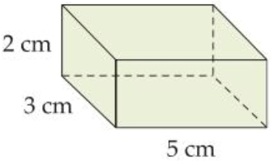 | Hegartymaths  Clip 568
Use the term-to-term rule for a sequence | Find the term to term rule and the next 2 terms of the sequence  5, 11, 17, … | Hegartymaths  Clip 197
Increase or decrease by a given percentage | Increase £40 by 15% | Hegartymaths  Clip 88
Find the position-to-term rule for a sequence | Find the position to term rule for this sequence:  2, 6, 10, 14, … | Hegartymaths  Clip 198
Draw the plan, front elevation and side elevation for a given solid | Draw the plan, front and side elevations for the following solid.  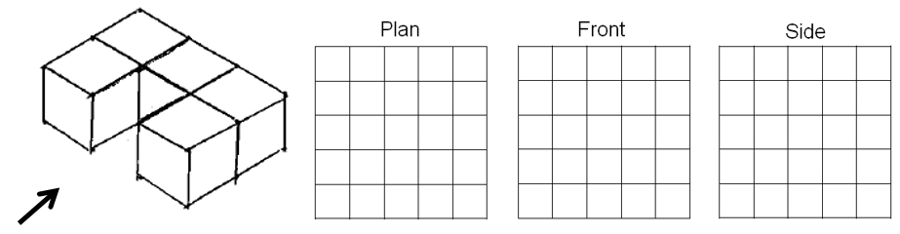

Language | Meaning | Example
Proportion | Compares a part to the whole | 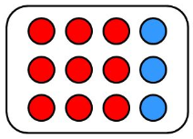  Proportion of red = $\frac{\text{9}}{\text{12}}$
Ratio | Compares two or more parts and is usually written using a colon | 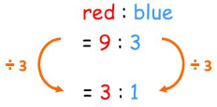
Simplify a ratio | Divide both sides of a ratio by their highest common factor
Scaling | Multiplying or dividing a pair of quantities to help solve a problem | 4 apples cost £1.25  ×2 ×2  8 apples cost £2.50
Unitary method | A method for solving proportion problems where you start by finding the value for one unit | 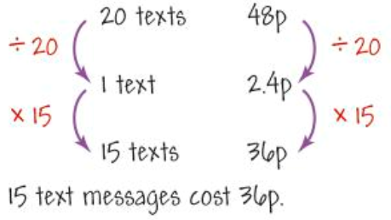
Direct proportion | Quantities are in direct proportion if when you increase one the other increases in the same proportion | The perimeter of a square is directly proportional to the length of one side: doubling the length of one side doubles the perimeter

Language | Meaning | Example
Probability | A measure of the chance that an event happens | The probability of a flipped coin showing tails is ½ or 0.5 or 50%. This is an evens chance
Evens chance | A 50% chance of happening
Equally likely | Events with the same chance of happening | For a fair dice: 1, 2, 3, 4, 5 and 6 are all equally likely.  The probability of each one is $\frac{\text{1}}{\text{6}}$.
Trial | A statistical experiment with an uncertain outcome | Throwing a dice to see which number is on top.
Outcome | A possible result of a trial | For a dice the possible outcomes are 1, 2, 3, 4, 5 and 6.
Event | A collection of outcomes | The event ‘an even number’ consists of the outcomes 2, 4 and 6
Experiment | A series of trials which can be used to estimate a probability | Rolling a dice 600 times and recording the outcomes is an experiment
Biased | A trail in which all the individual outcomes are not equally likely | 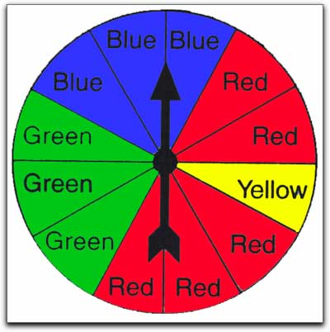  This is a biased spinner. There are more red than yellow sectors
Independent probability | Two events are said to be independent if and only if the occurrence of one event happening has absolutely no effect on the chances of the other event happening | What you have for tea and who wins the next world cup are independent events.
Mutually exclusive outcomes | Outcomes are mutually exclusive if they cannot happen at the same time | Rolling a dice once and getting a 6 and a 2 are mutually exclusive as they cannot happen at the same time.

Language | Meaning | Example
Relative frequency | The probability of an event, based on the actual frequency relative to the total possible frequency | If you have 10 hurdles to jump and succeed at jumping 8, your relative frequency is 80%
Experimental probability | $$\text{P}\left(\text{event}\right) \text{=} \frac{\text{number of times the event occurs}}{\text{number of trials}}$$  If you flip a coin 50 times and get 28 tails, the experimental probabiloity of tails is: $\text{P}\left(\text{tail}\right) \text{=} \frac{\text{28}}{\text{50}}$
Sample space diagram | A diagram which uses a table to record possible outcomes |  | 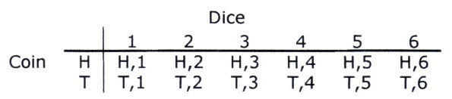
Venn Diagram | Uses circles to sort things into sets. The circles can overlap. |  | 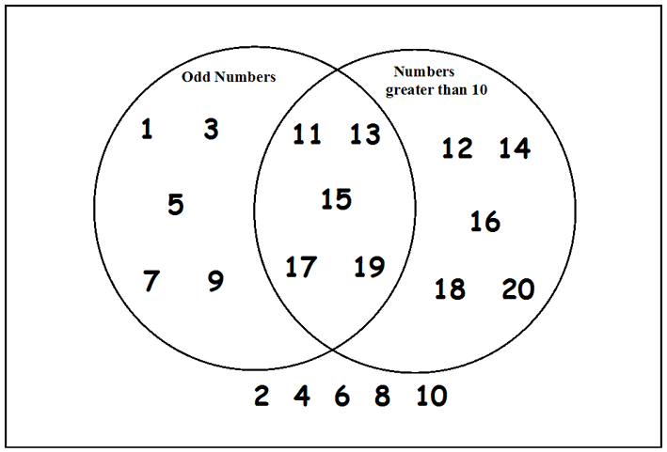
Tree diagram | A diagram which uses branches to record possible outcomes |  | 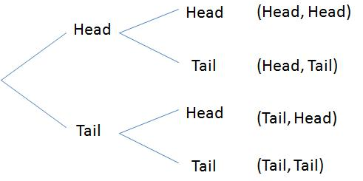
Simulation and model | Simulation is the imitation of the operation of a real-world process or system over time. The act of simulating something requires that a model be developed; this model represents the key characteristics of the selected system or process. The model represents the system itself, whereas the simulation represents the operation of the system over time  Computer simulations are a key feature of most of the working world.

Language | Meaning | Example
Solid | A shape formed in three dimensions. | 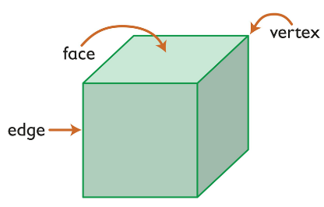
Vertex | The point on a 3D shape at which two or more edges meet (commonly known as the corner).
Edge | The line where two faces meet
Face | A surface of a solid.
Front elevation | The view of the shape from the front | 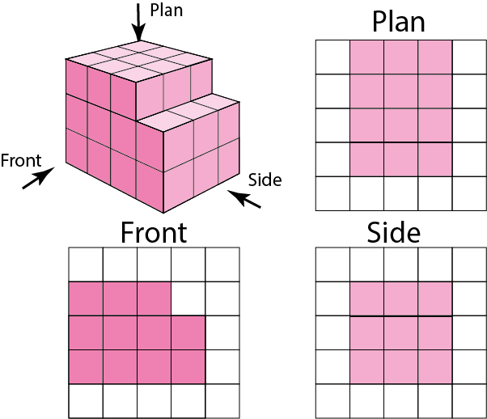
Side elevation | The side view of the shape
Plan | The bird’s eye view of the shape – the view from above
Net | A 2D shape that can be folded to form a solid | Here is a net for a cube.  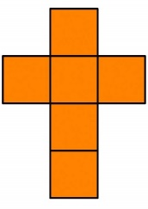
Surface area | The total area of all the faces of a solid shape | 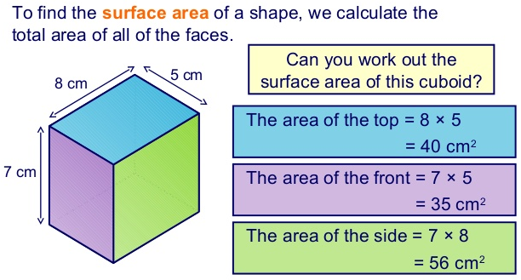
Volume | The amount of space inside a 3D shape
Cross section | The 2D shape made when a 3D solid is cut along its length. | 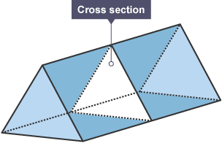

Language | Meaning | Example
Prism | A 3D shape with constant cross section | 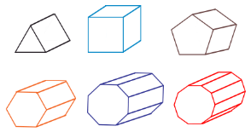
Pyramid | A 3D shape that tapers to a point | 