In this half term you will be regularly tested on these key skills:

Skill | Example | Support
Generating and describing a sequence | Generate the first four terms of this sequence:  First term is 5, rule is +8  What is the term-to-term rule for this sequence?  8, 17, 26, 35,… | Hegartymaths  Clip 197
Multiplying with decimals | Work out 4.9 × 7.7 | Hegartymaths  Clip 48
Dividing with decimals | Work out 120.4 ÷ 7 | Hegartymaths  Clip 49
Simplifying a ratio | Write this ratio in its simplest form: 21 : 14 | Hegartymaths  Clip 329
Direct proportion problems | 10 oranges cost £4.  What is the cost of 6 oranges? | Hegartymaths  Clip 339
Identify a fraction / proportion | In a packet of biscuits, 5 are broken and 30 are not.  What proportion of the biscuits are broken? | Hegartymaths  Clip 330
Times tables | Complete this multiplication grid:  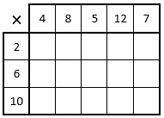 | 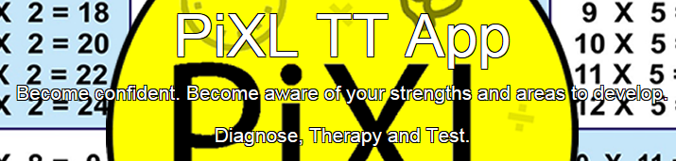  timestable.pixl.org.uk  School ID 5223

Objectives – Set 1
By the end of these units of work, you will have learned how to….
- Recognise and describe different kinds of data | - Construct angle bisectors and perpendicular bisectors
- Find the mean, median, mode and range for raw data and data in a frequency table | - Construct triangles accurately
- Construct and understand different types of bar charts and pie charts | - Describe a locus of a moving point and draw it accurately
- Create suitable data collection sheets | - Use and construct scale drawings
- Write questions which are clear, unbiased and easy to answer | - Name and describe 3D solids
- Collect discrete and continuous data in a grouped frequency table and find the modal class | - Draw plans, elevations and nets of 3D solids
- Compare sets of data

 | These are the homework clip numbers that are appropriate for this half term.
Statistics | Constructions and 3D Shapes
404 – Mode  405 – Mean 1  409 – Median  410 – Range  414 – Range from frequency tables  415 – Mode from frequency tables  416 – Median from frequency tables  417 – Mean from frequency tables 1  425 – Bar charts and vertical line graphs  427 – Pie charts 1  428 – Pie charts 2  429 – Pie charts 3  392 – Types of data 1  399 – Surveys & questionnaires 1  400 – Surveys & questionnaires 2  402 – Grouped frequency tables – discrete  403 – Grouped frequency tables - continuous | 660 – Construct a perpendicular bisector  661 – Construct an angle bisector  584 – Surface area of cuboids  568 – Cuboids 1

Objectives – Set 2 and 3
By the end of these units of work, you will have learned how to….
- Understand and draw different kinds of bar chart | - Draw triangles and quadrilaterals accurately using a ruler and protractor
- Understand pie charts | - Use and construct a scale drawing
- Understand and draw line graphs | - Know various 3D shapes and their names
- Find averages and range from a list of data | - Count the vertices, faces and edges of a 3D shape
- Collect data and recognise a good questionnaire | - Use isometric paper to draw 3D shapes
- Organise data using tally charts and frequency tables
- Compare data from lists or represented in diagrams

 | These are the homework clip numbers that are appropriate for this half term.
Statistics | Constructions and 3D Shapes
404 – Mode  405 – Mean 1  409 – Median  410 – Range  414 – Range from frequency tables  415 – Mode from frequency tables  416 – Median from frequency tables  425 – Bar charts and vertical line graphs  427 – Pie charts 1  428 – Pie charts 2  429 – Pie charts 3  392 – Types of data 1  401 - Data collection sheets (tally charts)  402 – Grouped frequency tables – discrete | 567 – Counting cubes  568 – Cuboids 1

Objectives – Set 4
By the end of these units of work, you will have learned how to….
- Plan how to collect and organise small sets of data from surveys and experiments | - Recognise and name common 3D shapes
- Solve problems by interpreting data in lists and tables | - Construct simple nets of 3D shapes
- Construct and interpret statistical diagrams, including pictograms, bar charts, pie charts and line graphs | - Use 2D representations to visualise 3D shapes
- Calculate statistics for small sets of data, including the mode, median and range | - Use a protractor to measure and draw angles
 | - Use a ruler and protractor to construct a triangle
 | - Know the parts of a circle

 | These are the homework clip numbers that are appropriate for this half term.
Statistics | Constructions and 3D Shapes
399 – Surveys & questionnaires (1)  401 – Data collection sheets (tally charts)  415 – Mode from frequency tables  426 – Pictograms  427 – Pie charts (1)  428 – Pie charts (2)  429 – Pie charts (3)  404 – The mode  409 – The median  410 – Range | 568 – 2D representations of 3D shapes  458 – Measuring angles 1  461 – Drawing angles

Language | Meaning | Example
Primary Data | Data you collect yourself | If you recorded the colour of each car passing your school for an hour, this would be primary data
Secondary data | Data which has already been collected by someone else | Data on the internet is secondary data
Questionnaire | An organised list of questions, often with options for answers
Frequency Table | A table that shows how often a particular item of data occurs. It often includes a tally column. | 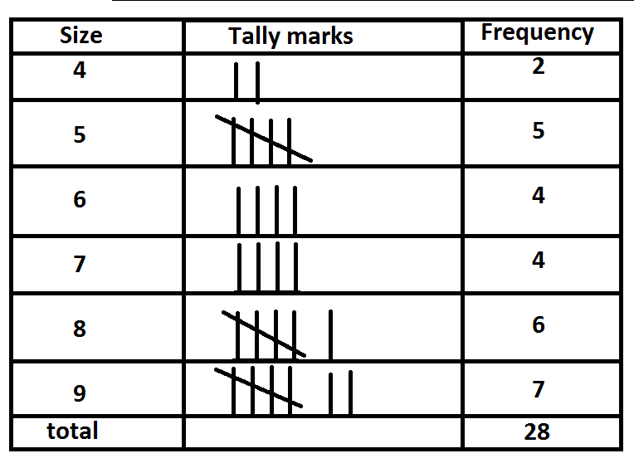
Pictogram | A diagram that shows data as a series of pictures. | 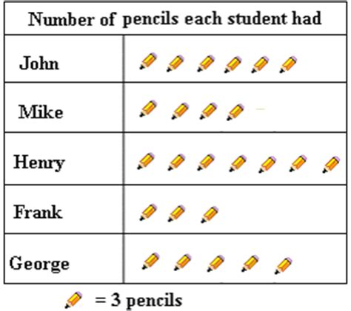
Bar chart | A diagram that uses rectangles to represent frequency | 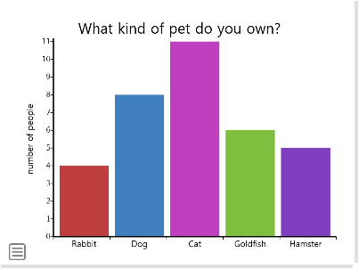
Pie chart | A diagram that uses a circle to display data in proportion | 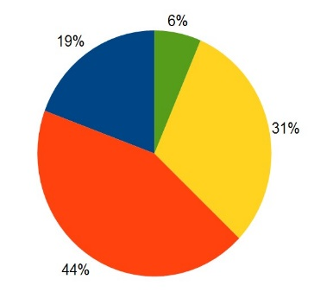
Line graph | A graph that shows plotted points joined by straight lines | 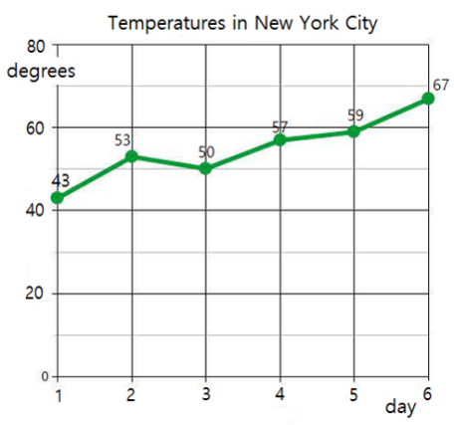
Grouped data | Data that is organised into class intervals | 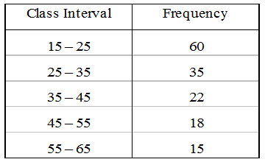
Average | A representative value for a set of data | The mode, median and mean
Mode | The data value that occurs most often | Data: 3, 2, 5, 8, 5, 6, 2, 5  Ordered: 2, 2, 3, 5, 5, 5, 6, 8  Mode = 5  Median = (5 + 5) ÷ 2 = 5  Mean = (2 + 2 + … + 8) ÷ 8  = 36 ÷ 8 = 4.5
Median | The middle value when data are sorted into numerical order. If there are two values in the middle, the median is found by adding the two values and dividing by 2.
Mean | An average defined as the sum of all of the data values divided by the number of data values
Range | The difference between the highest and lowest values in a set of data | For the data above:  Range = 8 – 2 = 6

Language | Meaning | Example
Vertex | The point on a 3D shape at which two or more edges meet (commonly known as the corner). | 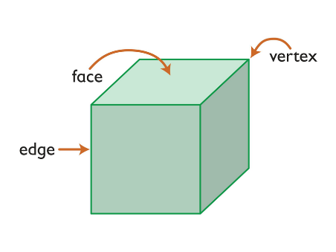
Edge | The line where two faces meet
Face | A surface of a solid.
Net | A 2D shape that can be folded to form a solid. | Here is a net for a cube.  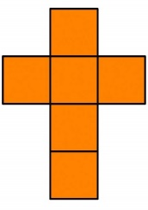
Pyramid | A 3D shape that tapers to a point | 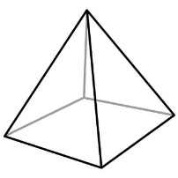
Tetrahedron | A pyramid in which each face is a triangle | 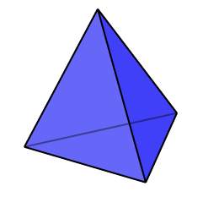
Prism | A 3D shape that has a constant cross section | 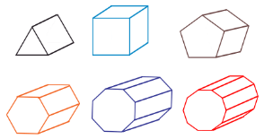
Volume | The amount of space inside a 3D shape
Radius | The distance from the centre to the edge of a circle. The radius is half of the diameter. | 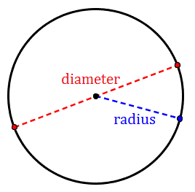
Diameter | The distance across a circle through the centre. The diameter is double the radius.
Circumference | The distance around the edge of a circle.
Construct | To draw a line, angle or shape accurately. | 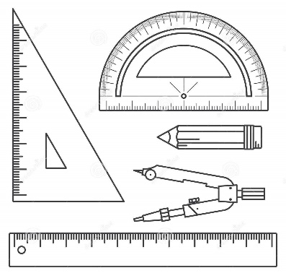
Bisector | An angle bisector splits an angle into exactly two equal halves.  A perpendicular bisector crosses a line and divides it into two equal halves. | 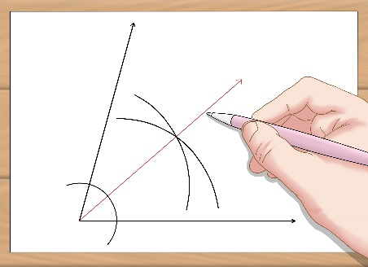  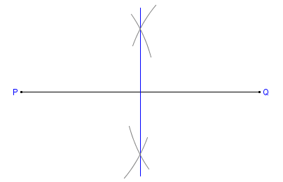
Locus | The locus of an object is its path. | The locus of points 3cm from A is a circle, radius 3cm with centre A.
Scale drawing | A drawing that represents an object to a given scale | 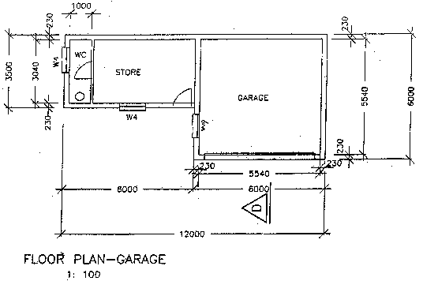
Elevation | An accurate drawing of the side or front of a solid. | 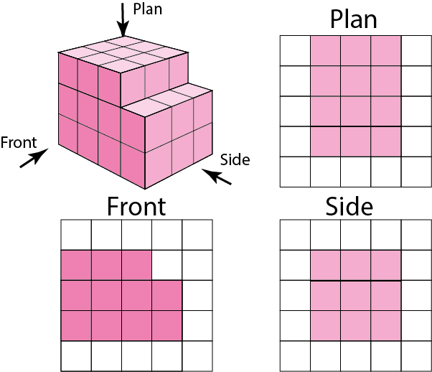
Plan | The view of a solid from above

