Religious Education
Islam

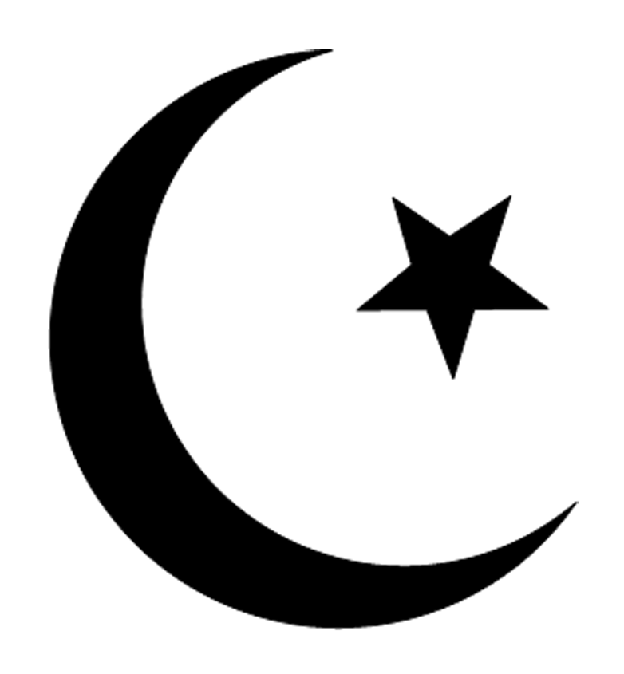

Year 7
Term 3
Key Words
Allah | The Arabic word for God. There are 99 names to describe the qualities of Allah.
Islam | The name of the religion that Muslims follow.
Muslim | A follower of Islam.
Muhammad | The founder of Islam.
Mosque | The place where Muslims worship.
Prophet | Holy people, through whom Allah has revealed something of himself.
Tawhid | The most important belief about Allah (God) in Islam is the concept of Tawhid, which means ‘oneness’. Tawhid begins with the idea that there is one God (monotheism), and teaches that oneness is central to the nature of Allah.
Shirk | The sin of idolatry or associating beings or things with Allah.
Qur’an | The holy book of Islam.
Surah | A division (chapter) of the Qur’an. There are 114 in all.
The Five Pillars of Islam | Five obligatory practices Muslims must follow: Shahadah, Salah, Zakat, Swam and Hajj.
Shahadah | Declaration of faith; one of the Five Pillars of Islam. “I bear witness that there is no god but Allah and that Muhammad is His messenger”
Salah | Obligatory set prayer five times a day; one of the Five Pillars of Islam.
Zakat | Purification of wealth by payment of annual welfare due (2.5% of spare wealth); one of the Five Pillars of Islam.
Sawm | Fasting in the month of Ramadan; one of the Five Pillars of Islam.
Hajj | An annual pilgrimage to Mecca which every Muslim should aim to make as long as health and wealth allow at least once in their life time; one of the Five Pillars of Islam.
Wudu | The ritual act of washing before prayer.
The Ka'aba | The black covered cube-shaped building in the center of the grand mosque in Mecca. All Muslims face towards it when they pray.
Mecca | The city where Muhammad was born. The spiritual centre of Islam, it is in Saudi Arabia.
Rak’ahs | Actions made during salah consisting of recitations, standing, bowing and prostration
Akhirah | After death, all people will be raised from the dead to face Allah’s judgement. This is a physical resurrection.
Hadith | a collection of traditions containing sayings of the prophet Muhammad which are the major source of guidance for Muslims apart from the Qur’an.

Allah
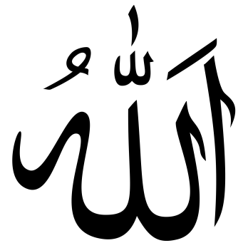
The fact that God is called Allah (the God) in Arabic tells you a lot about the Muslim concept of God. Allah is simply the word for God and is not the name for some other being. Allah has no plural in Arabic. It cannot be made to refer to more than one and so the fact that the Qur’an uses the word ‘Allah’ ‘means that there is only one God.
Basic concepts about Allah:
Tawhid – Oneness of Allah. Monotheism – belief that there is only one God. This means Allah;
- has no partners,
- is omniscient (knows all things),
- is omnipotent (can do anything,
- is all-powerful) and
- is the one God of all time and all humankind.
The belief in Tawhid forms the central part the Shahadah, the declaration of faith, which is the first of the Five Pillars of Islam (the duties that all Muslims have to perform as their religious practice) “I bear witness that there is no God but Allah and that Muhammad is His messenger”
Shirk – the division of the unity of Allah, sin of polytheism, unforgiveable sin. It is the opposite of Tawhid. Associating other beings with God. Shirk also occurs if one believes other gods exist and they share power with Allah.
Anyone who commits shirk can no longer be considered a Muslim as it is considered the one unforgiveable sin.
Many different names are used to describe Allah in the Qur’an and the Hadith These are sometimes referred to as ‘the 99 names of Allah’.
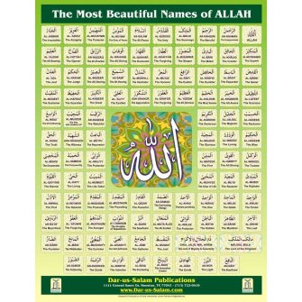
Allah cannot be described by any or all of
these names but they help Muslims to think
about Allah’s unknowable nature. Many
Muslims recite the names as one of the
forms of dhikr (remembrance) to develop
their awareness of Allah. Some Muslims
use prayer beads (subha) to help them remember as they recite. Some examples of the 99 names:
The Qur’an state: “Say: He is Allah, the One and Only; Allah, the Eternal, Absolute; None is born of Him, nor is He born; And there is none like Him.” | “I bear witness that there is no god but God and that Muhammad is His messenger” | There are 99 names of Allah; he who commits them to memory would get into paradise.
- Al-Rahman, the All-beneficent (the Compassionate),Al-Rahim, the Most Merciful, Al-Aziz, the Almighty (the Victorious), Al-Hakam, the Judge.
There are no pictures in mosques because of tawhid. The only art you find is calligraphy or geometric patterns. Some Muslims do not allow photographs. The belief is that any form of representational art might lead you to worship the art rather than the creator.
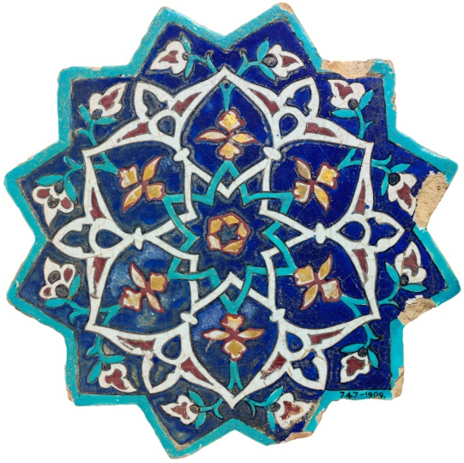

Life & Times of Islam’s Prophet, Muhammad (PBUH).
Muhammad was born in a city called Mecca, in what is today called Saudi Arabia. He was born in about 570CE/AD. Muhammad had a very hard childhood, his father died before he was born and his mother died when he was only six years old. As a young man, Muhammad was already well known for his honesty and goodness. He worked in Mecca for a wealthy woman called Kadijah. He married Kadijah when he was 25. They were very rich and very happy.
However, Muhammad became more and more worried about the things that were happening in Mecca. He saw rich people cheating the poor, and people spending their time gambling, drinking and fighting. Idol worship was common, and often included sacrifices. Muhammad was sure that these things were wrong and went off to the mountains outside Mecca so that he could meditate.
Muhammad’s Vision
One night, Muhammad was meditating in a cave on Mount Hira when he had a vision. In his vision, an angel came to him carrying words written on a piece of cloth. The angel said ‘recite!’ Muhammad said that he could not read, but then found himself able to understand the words and read them aloud. He stood up and walked out of the cave, and heard the angel saying, ‘Muhammad! You are Allah’s messenger!’ Muhammad then went back to the people and recited what he had been told by the angel.
Muhammad was terrified by this experience and went home to tell Kadijah about it. She comforted him and was the first person to believe his message came from Allah. Muhammad began preaching to the people in Mecca, but he became unpopular. Although a few people believed what Muhammad was telling them, most of the people did not like being told they were sinners. Many people were against him, so in 622 Muhammad accepted an invitation from the people in the nearby town of Medina. They had heard about his preaching and had asked him to go and teach them. This was the beginning of the spread of Islam.
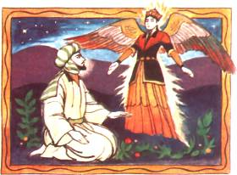
The Qur’an Revelation & Muhammad’s importance to
Muslim belief
Muslims believe that the Qur’an was revealed from God to Muhammad through the angel Jibril (Gabriel) from 610 to 632 CE, the year of his death. Muhammad recited the Qur’an to his followers, numbering tens of thousands, who recited after him, until they had memorized it. He also dictated it to his scribes (remember Muhammad was illiterate) who wrote down its verses during his life. Shortly after Muhammad's death the Qur’an was established as a single book.
Muhammad is important to Muslims because he sets the example of:
- how to live a Muslim life,
- how to be a faithful servant of Allah,
- how to keep on the straight path of Islam.
This is important to Muslims because he completed the message of Allah, he is the last Prophet of Allah (After Adam, Abraham, Moses & Jesus), he brought the message of Allah to ALL people for their salvation, PBUH (Peace Be Upon Him).
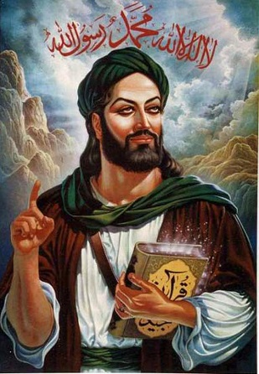
Quotes form the Prophet Muhammad
“It is your own conduct which will lead you to reward or punishment, as if you had been destined therefore.” | “ We are all equal like the teeth of a comb” | “Seek knowledge from the cradle to the grave.” | “Feed the hungry and visit a sick person, and free the captive, if he be unjustly confined. Assist any person oppressed, whether Muslim or non-Muslim.”

The Qu’ran

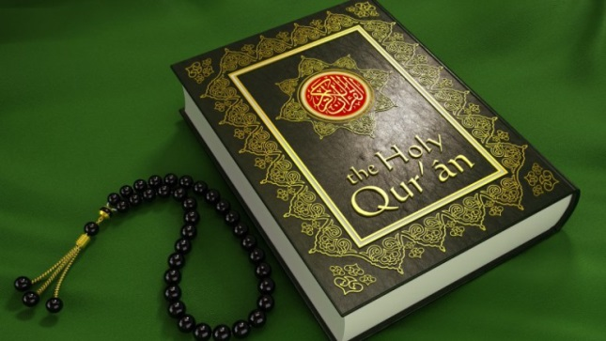

Scripture is the most important type of revelation for Muslims. The Qur’an is regarded as a special revelation from Allah to Prophet Muhammad. It was revealed to him in Arabic. The Qur’an is therefore different from any other book for Muslims because it contains the words of Allah.
In 611 CE the Prophet Muhammad was meditating in a cave when the Angel Jibril appeared to him. Muhammad could not read but three times Jibril ordered him to ‘recite’. The angel said:
Proclaim! In the name of thy Lord and Cherisher, who created – created man, out of a (mere) clot of congealed blood. Proclaim! And thy Lord Is Most Bountiful! He who taught (the use of) the pen taught man that which he knew not. Surah 96:1-5

The messenger of Allah
Jibril then told Muhammad that he was to be the messenger of Allah. These revelations continued for the next 23 years and the final verse was:
‘This day I have perfected your religion for you, completed My favour upon you, and have chosen for you Islam as your religion.’
Surah 5:4
Muhammad remained unable to read and the Qur’an was written down by his friends and followers. The Qur’an has 114 Surahs (or chapters). These are arranged by length, not by chronological order.

An Arabic text
For Muslims the Qur’an contains only the literal unchanged words of Allah. It is direct revelation from Allah (God) to humanity. Because the Qur’an is the word of Allah it cannot be criticised. To do so would be seen as not only irrelevant but, most importantly, it would be disrespectful.
Also to preserve the true words of God, the Qur’an is always read and studied in Arabic. Versions of the Qur’an in other languages are not called translations because the true meaning of the words can only be found in the Arabic. The Qur’an is Iman (faith), unchanging and unchangeable. It is the last and most complete book of guidance from Allah and applies to all people forever.
In his sermon on Mount Arafat, Muhammad made it clear that this was the final revelation: "No prophet or messenger will come after me and no new faith will emerge."

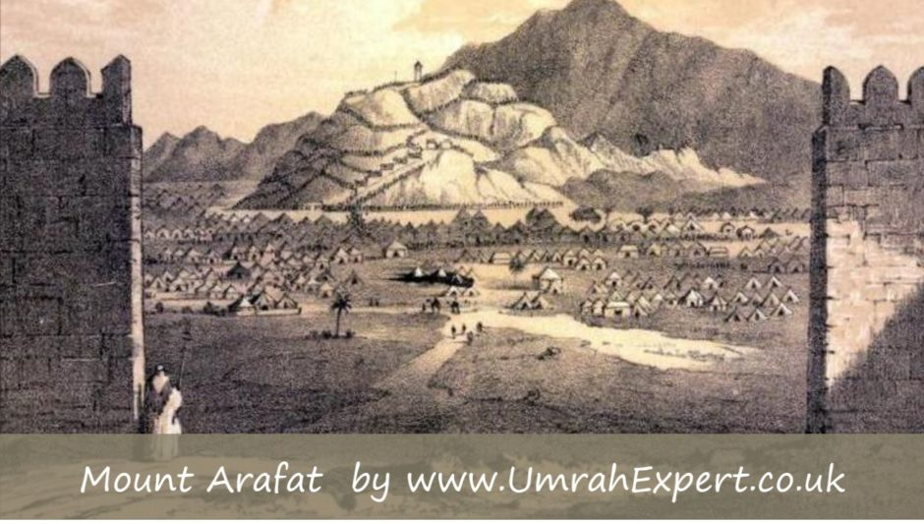
"Forbidden to you (for food) are: dead meat, blood, the flesh of swine, and that on which hath been invoked the name of other than Allah." | "You shall glorify and praise your Lord and be with the prostrators, and worship your Lord “ | “Say: He is Allah, the One and Only; Allah, the Eternal, Absolute; None is born of Him, nor is He born; And there is none like Him.”
O YOU who have attained to faith! Fasting is ordained for you as it was ordained for those before you, so that you might remain conscious of God. | “Paradise is for those who curb their anger and forgive their fellow men”

The Five Pillars of Islam

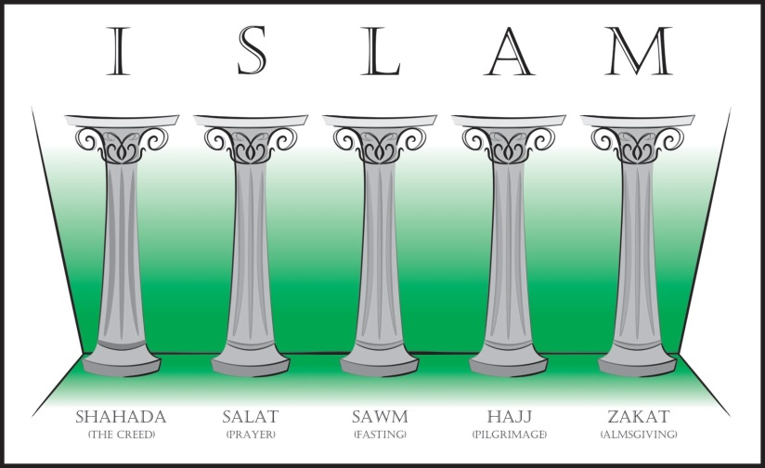
The most important Muslim practices are the Five Pillars of Islam. The Five Pillars of Islam are the five obligations that every Muslim must satisfy in order to live a good and responsible life according to Islam. The Five Pillars consist of:
- Shahadah: sincerely reciting the Muslim profession of faith.
- Salat: performing ritual prayers in the proper way five times each day.
- Zakat: paying an alms (or charity) tax to benefit the poor and the needy.
- Sawm: fasting during the month of Ramadan.
- Hajj: pilgrimage to Mecca.

Why are they important?
Carrying out these obligations provides the framework of a Muslim's life, and weaves their everyday activities and their beliefs into a single cloth of religious devotion.
No matter how sincerely a person may believe, Islam regards it as pointless to live life without putting that faith into action and practice. Carrying out the Five Pillars demonstrates that the Muslim is putting their faith first, and not just trying to fit it in around their secular lives.

Shahadah

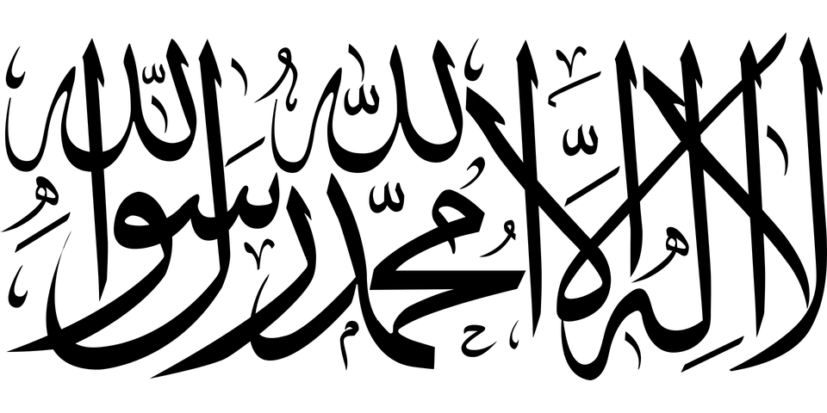
"There is no God but Allah, and Muhammad is his messenger."
This is the basic statement of the Islamic faith: anyone who cannot recite this wholeheartedly is not a Muslim.
When a Muslim recites this they proclaim:
- That Allah is the only God, and that Muhammad is his prophet.
- That they personally accept this as true.
- That they will obey all the commitments of Islam in their life.
The Shahadah is the first of the Five Pillars of Islam.

Becoming a Muslim
Reciting this statement three times in front of witnesses is all that anyone need do to become a Muslim.

Salat

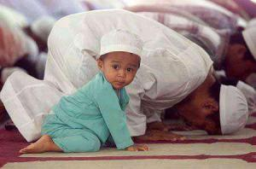
Salat is the obligatory Muslim prayers, performed five times each day by Muslims. It is the second Pillar of Islam.
God ordered Muslims to pray at five set times of day:
- Salat al-fajr: dawn, before sunrise
- Salat al-zuhr: midday, after the sun passes its highest
- Salat al-'asr: the late part of the afternoon
- Salat al-maghrib: just after sunset
- Salat al-'isha: between sunset and midnight
All Muslims try to do this. Muslim children as young as seven are encouraged to pray.

Prayer sets the rhythm of the day
This prayer timetable gives Muslims the pattern of their day. In Islamic countries, the public call to prayer from the mosques sets the rhythm of the day for the entire population, including non-Muslims.

A universal Muslim ritual
The prayer ritual, which is over 1400 years old, is repeated five times a day by hundreds of millions of people all round the world.
Carrying it out is not only highly spiritual, but connects each Muslim to all others around the world, and to all those who have uttered the same words and made the same movements at different times in Islamic history.

Prayers of body, mind and soul
The set prayers are not just phrases to be spoken.
Prayer for a Muslim involves uniting mind, soul, and body in worship; so a Muslim carrying out these prayers will perform a whole series of set movements that go with the words of the prayer.
Muslims make sure that they are in the right frame of mind before they pray; they put aside all every day cares and thoughts so that they can concentrate exclusively on Allah.
If a Muslim prays without the right attitude of mind, it as if they hadn't bothered to pray at all.

Muslims don't pray for God's benefit
Muslims do not pray for the benefit of Allah.
Allah does not need human prayers because he has no needs at all.
Muslims pray because God has told them that they are to do this, and because they believe that they obtain great benefit in doing so.

Muslims pray direct to God
A Muslim prays as if standing in the presence of Allah.
In the ritual prayers each individual Muslim is in direct contact with Allah. There is no need of a priest as an intermediary. (While there is a prayer leader in the mosque - the imam - they are not a priest, simply a person who knows a great deal about Islam.)

Praying in the mosque
Muslims can pray anywhere, but it is especially good to pray with others in a mosque.
Praying together in a congregation helps Muslims to realise that all humanity is one, and all are equal in the sight of Allah.

Ritual washing
Muslims must be clean before they pray. They make sure of this by performing ritual washing, called wudu. Mosques have washing facilities.
Zakat
Zakat is the compulsory giving of a set proportion of one's wealth to charity. It is regarded as a type of worship and of self-purification. Zakat is the third Pillar of Islam.
Zakat does not refer to charitable gifts given out of kindness or generosity, but to the systematic giving of 2.5% of one's wealth each year to benefit the poor.
The benefits of Zakat, apart from helping the poor, are as follows:
- Obeying God.
- Helping a person acknowledge that everything comes from God on loan and that we do not really own anything ourselves.
- And since we cannot take anything with us when we die we need not cling to it.
- Acknowledging that whether we are rich or poor is God's choice, so we should help those he has chosen to make poor.
- Learning self-discipline.
- Freeing oneself from the love of possessions and greed.
- Freeing oneself from the love of money.
- Freeing oneself from love of oneself.
- Behaving honestly.

Sawm

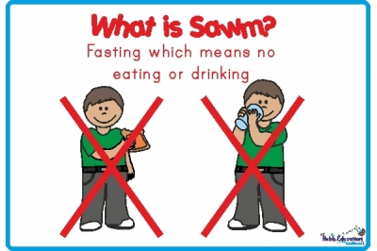

Sawm is fasting. It's the fourth of the Five Pillars of Islam.
Muslims are required to fast during Ramadan, the ninth month of the Islamic calendar.
During the 29/30 days of Ramadan all adult Muslims must give up the following things during the hours of daylight:
- Food or drink of any sort
- Smoking, including passive smoking
- Sexual activity
Muslims who are physically or mentally unwell may be excused some of these, as may those who are under twelve years old, the very old, those who are pregnant, breast-feeding, menstruating, or travelling.
If an adult does not fast for the reasons above they should try to make up the fast at a later date, or make a donation to the poor instead.
Muslims do not only abstain from physical things during Ramadan. They are also expected to do their best to avoid evil thoughts and deeds as well.
There are many good reasons for this fast, including:
- Obeying God.
- Learning self-discipline.
- Becoming spiritually stronger.
- Appreciating God's gifts to us.
- Sharing the sufferings of the poor and developing sympathy for them.
- Realising the value of charity and generosity.
- Giving thanks for the Holy Qur'an, which was first revealed in the month of Ramadan.
- Sharing fellowship with other Muslims.

Eating in Ramadan
During Ramadan many Muslims will try to eat a large meal called suhur just before dawn.
When daylight is over, most Muslims will break or open the fast with dates or water, following the example of the Prophet Muhammad, before having a proper meal later.
The evening meals during Ramadan are occasions for family and community get-togethers.
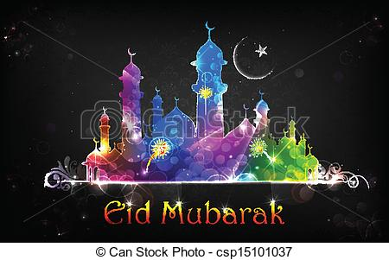

Eid ul-Fitr
The month of Ramadan ends with the
festival of Eid ul-Fitr. This is marked by dressing up and visiting the mosque for prayer, and with visits to family and friends for celebratory meals.

Ramadan and the Western calendar
Because Islam uses a lunar calendar, the month of Ramadan comes around 11 days earlier each successive year, so there is no Western season associated with Ramadan.
" Ramadan is the (month) in which the Qur’an was sent down, as a guide to mankind and a clear guidance and judgment (so that mankind will distinguish from right and wrong).." (Q 2:183) | "... whoever fasts during Ramadan out of sincere faith and hoping to attain Allah's rewards, then all his past sins will be forgiven.“ (Muhammad)

Hajj
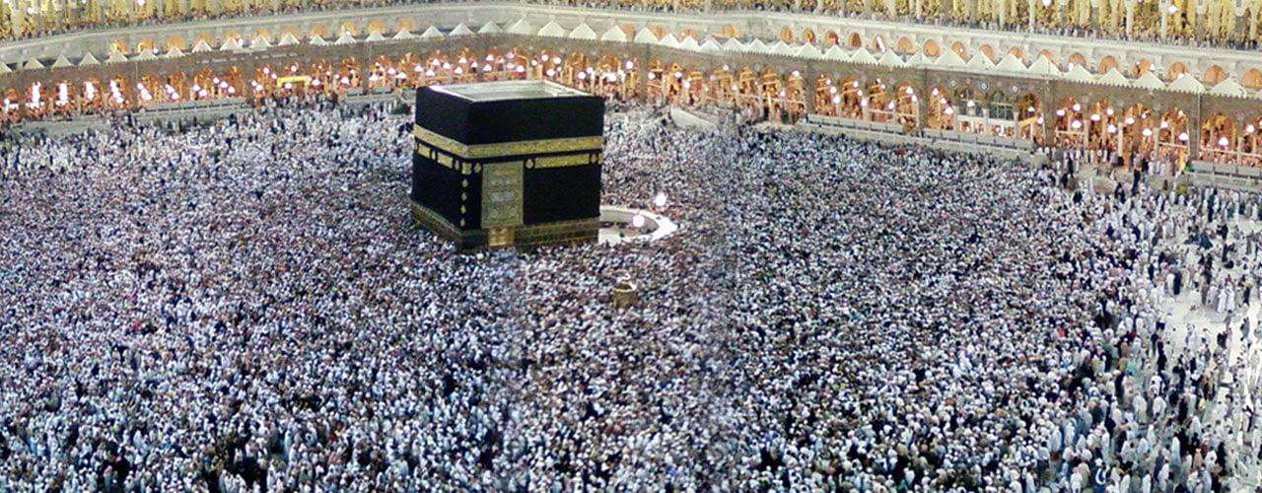
Hajj is the fifth and final pillar of Islam. It is the pilgrimage to Mecca, in Saudi Arabia, the birthplace of Islam. Hajj takes place in the twelfth month of the Islamic calendar and every Muslim who is physically and financially able, must perform this pilgrimage at least once in their lifetime. It is a rigorous journey - a reminder of the purpose of life and man's ultimate end.
Muslims believe that if their pilgrimage is accepted, all of their sins are washed away.
The Hajj is an act of remembrance of the footsteps of the Prophet Abraham who is revered in Islam. Abraham is regarded as the Father of the Prophets, from whose lineage came Moses, Jesus and Muhammad. Both Mecca and Medina are extremely sacred lands for Muslims, because of their association with Abraham and Muhammad. It is also a reminder of death, and therefore the purpose of life.
Ihram
Ihram is the changing of the mental state to that which is most sacred. Pilgrims prepare to communicate with God in what is believed to be the world's most sacred ground.
All men wear the same clothing: two sheets of plain white, unhemmed cotton. This dress is a mark of equality between all humans. It is also a reminder of the shroud Muslims wear in death. For the sake of modesty, women do not have to conform to this dress and may wear any modest clothing and may not cover their face.
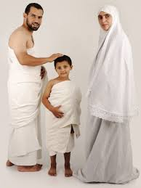
Umrah
Pilgrims then walk between two mountains called Safa and Marwa, which are a distance of around 500 yards apart, seven times. This in remembrance of Hagar, who searched between these mountains looking for water for Ishmael, before the Zam Zam water was found.
Pilgrims then drink from the Zam Zam well. This well is believed to be the one Ishmael and Hagar, son and wife of Prophet Abraham, drank from when they were left in the area.
Arafat
At dawn, pilgrims then make their way to the plain of Arafat. Arafat is the most important part of the Hajj. It is a reminder of the Day of Judgement, where Muslims believe mankind will stand on a similar plain, in scorching heat, waiting for judgement. It is also a reminder of another scene on the Day of Judgement. All humans will be grouped together with those of similar belief, just as those in Hajj often group together according to country, city and language.
Muslims spend the entire day in Arafat, praying to God and thinking over the purpose of their lives. It is an extremely emotional time.
Jamaraat
After leaving Muzdalifah, pilgrims make their way over to the Jamaraat. The Jamaraat are three tall, stone pillars which represent Satan. The pillars remind pilgrims of the three temptations that were presented to Abraham as he was getting ready to sacrifice his son. Just as Abraham resisted the temptations, pilgrims symbolically reject Satan and all of life's temptations, by throwing pebbles at the pillars.
Sacrifice
On the day of Eid, Muslims must distribute what is known as Qurbani. This is the slaughter of an animal, which is then given to the poor of the community on Eid day. This is done all over the world.
Pilgrims traditionally oversaw the sacrifice of their animals themselves, but there are now too many people to do this efficiently. Therefore, Muslims buy vouchers which guarantee that an animal will be sacrificed for them. After the pilgrims have left the Jamaraat, the animal will already have been sacrificed on their behalf and the meat given to the poor
Farewell Tawaf
The final act of Hajj is the farewell Tawaf. Tawaf is the Arabic word for the circling of the Ka’bah seven times. After this, the Hajj is complete. Many people then visit the city of Medina, which became Muhammad's home city.

Islam – War and Peace
Muslim attitudes to war and peace are based on the teachings of the Qur’an (the Divine Book revealed to the Prophet Muhammad). There are two ideas in Muslim teaching that relate to war – Jihad (to struggle in the way of Allah) and Harb al-Muqadis (Holy War).
Islam is a religion which advocates peace and peace-making. However, it is not a pacifist religion; fighting and war is permitted in certain circumstances when all else has been tried and failed.

Jihad

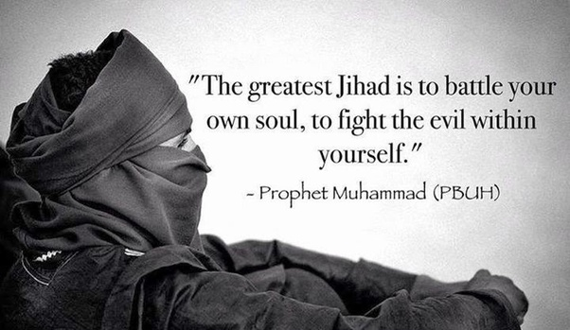
Jihad means ‘to strive or struggle in the way of Allah’. There are different levels of Jihad:
- Greater Jihad the personal spiritual struggle or effort of every Muslim to follow the teachings of Allah (God) in their own lives e.g.
- overcoming things such as anger greed,
- pride and hatred,
- forgiving someone who has hurt them,
- working for social justice.
- Lesser Jihad the struggle to build a good Muslim society, also Holy War (the struggle to defend against oppression, with force if necessary).
When the Prophet Muhammad was asked which people fought in the name of Allah, he said: "The person who struggles so that Allah’s word is supreme is the one serving Allah’s cause".
The idea of Jihad is often misunderstood.
Most Muslim scholars believe that the internal struggle is the Greater Jihad, based on something the Prophet Muhammad said. There are some scholars who believe that this is unreliable and that ‘jihad’ meaning Holy War is the more important meaning.

Harb al-Muqadis - Holy War
‘The Qur’an makes it clear that Muslims may fight in self-defence but should not start a fight or war. Other reasons for a military jihad include:
- to strengthen Isla,m,
- to protect the freedom of Muslims to practice their faith,
- to protect Muslims against attack; to put right a wrong.
A military jihad has to follow strict rules in order to be legitimate:
- The opponent must have started the fighting.
- It must not be fought to gain territory.
- It must be launched by a religious leader.
- It must be fought to bring about good – something that Allah would approve of.
- It must be a last resort – all other ways of solving the problem must have been tried.
- Innocent people should not be killed; women, children or old people should not be killed or hurt.
- Women must not be raped or abused in any way.
- Enemies must be treated with justice.
- Wounded enemy soldiers must be treated in exactly the same way as one’s own soldiers.
- The war must stop as soon as the enemy asks for peace.
- Property must not be damaged.
- Poisoning of wells is forbidden (chemical or biological warfare might be a modern analogy).
O mankind! We created you from a single (pair) of a male and a female, and made you into nations and tribes, that ye may know each other (not that ye may despise each other). Verily the most honoured of you in the sight of Allah is (he who is) the most righteous of you.  Surah 49:13 | Do not let your hatred of a people incite you to aggression."  “Good deeds and evil deeds are not equal. Requite evil with good, and he who is your enemy will become your dearest friend.”  Qur’an 41:34 | "And do not let ill-will towards any folk incite you so that you swerve from dealing justly. Be just; that is nearest to heedfulness"
“If they incline to peace, make peace with them, and put your trust in God. It is surely He who hears all and knows all.” | “Fight for the sake of God those that fight against you, but do not attack them first.”  Qur’an 2:190 | “Paradise (is for those) who curb their anger and forgive their fellow men.”  Qur’an 3:134.

Check your knowledge – these are the questions that your teacher will ask you throughout the topic.

- What does the word Islam mean?
- What is the name of the holy book of Islam?
- State three Islamic beliefs about God.
- What is the holy book of Islam?
- What is the Islamic statement of faith?
- State three beliefs that Muslims and Christians both share.
- Allah comes from an Arabic word. What does it mean?
- What does monotheistic mean?
- State three beliefs that Muslims have about God.
- Record one of the 99 names of Allah.
- Record one quote from the Qur'an about Allah.
- What does prophet mean?
- Where was Muhammad born?
- Who revealed the Qur’an to Muhammad?
- What should Muslims say after Muhammad’s name is mentioned?
- Where did Muhammad go to meditate?
- Who was the first person to accept Islam?
- Record one of Muhammad's sayings.
- What is the Islamic statement of faith?
- What do Muslims mean by the 5 Pillars of Islam?
- List the 5 Pillars of Islam.
- How many times a day should Muslims pray?
- What does zakat mean?
- In what month do Muslims fast?
- Why do Muslims fast?
- What does the word Qur’an mean?
- How many years did it take to reveal the Qur’an?
- In what language is the Qur’an written?
- What is the first line of the Qur’an?
- How many chapters are there in the Qur’an?
- What does TAWHID mean?
- What must Muslims perform before they pray?
- How many times a day should Muslims pray?
- Where do Muslim face to pray? Why?
- Why do Muslims have a ritual wash before they pray?
- What do Muslims pray for when they wash their neck?
- Explain why Muslims bow down and prostrate in prayer.
- What does the word zakat actually mean?
- How often are Muslims to pay zakat?
- How much is zakat?
- Where does zakat go?
- Explain how zakat is fair.
- What does pilgrimage mean?
- True or False. Muslims have to on hajj/pilgrimage every year.
- Why do Muslims go to Mecca on hajj?
- How long is Hajj?
- What do Muslims wear on hajj? Why?
- When Muslims go on Hajj why do they run between Mount Sa’fa and Marwa
- When Muslims go on Hajj they will perform the ‘Tawaf’;what is Tawaf?
- What is the Arabic word for Mosque and what does it mean?
- Who built the first Mosque? Where? Why?
- When a Muslims enters a Mosque they will…because
- Then they will go to the washing room to…
- Outside a Mosque there is a m____. This is where the m_____ (CALL TO PRAYER)
- Inside a Mosque there is a prayer hall. In the prayer hall you will see…. M/M/ P.M
- In a Mosque there are no….because `
- What does Islam mean?
- What does jihad mean?
- What are the two types of Jihad?
- What does greater jihad mean?
- What does lesser jihad mean?
- State a criteria for a war to be consider jihad.
- "Do not let your hatred of a people incite you to aggression."
- What does this quote mean?

