Year 8 Knowledge Booklet
The Civil War

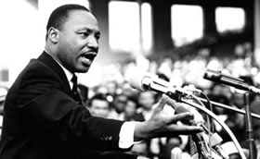
Knowledge Organiser
1865 Slavery in the USA was abolished
1954 Brown vs the Board of Education
1955 Montgomery Bus Boycott
1957 Little Rock
1961 Freedom Rides
1963 March on Washington
Assassination of John F Kennedy
1964 Civil Rights Act

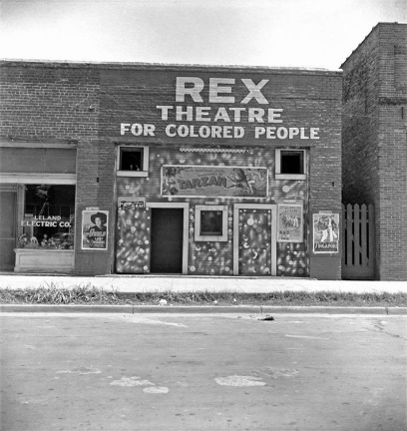
From Slavery to Segregation and Discrimination
Slavery did not end in the US until 1865- after the American Civil War. However black Americans were not made free and equal by the abolition of slavery. Black Americans continued to be treated like second class citizens. Many states, particularly in the South, chose to persecute black people and limit their rights. They passed what became known as ‘Jim Crow Laws’ designed to segregate blacks and whites in daily life. These ‘segregation laws’ meant that black people were forced to live separately from white people. They were given separate seats on buses and cinemas. Public benches, toilets and water fountains were labelled for use by ‘white’ people or ‘coloured’ people. In many Southern states it was hard for black people to vote.

Wise Words
Boycott Equality
Protest Voting Rights
Demonstration Equal Rights
Non Violence Struggle
Freedom Respect
Segregation Integration
Jim Crow Sit ins

Knowledge Box
1954: Brown versus Board of Education of Topeka was a landmark case. With the help of the NAACP, Rev Brown won the right in the Supreme Court to send his child to a white school.
1955: Rosa Parks refused to give up her seat on a bus to a white man. Black people in Montgomery, Alabama, led by Martin Luther King, refused to use the buses until the Town Council abolished segregated buses.
1957: Nine black students exercised their right to go to a white school in Little Rock, Arkansas. Mobs threatened the students. Even the governor of Arkansas tried to stop them by sending in the National Guard. President Eisenhower eventually took charge and used soldiers to protect the students.
1960: Sit-ins took place when black students went and sat in white restaurants until they were attacked and thrown out.
1961: Freedom Riders were black and white activists who travelled together on interstate buses – many were badly beaten by white mobs.
1963: A civil rights march in Birmingham, Alabama, was attacked by police and white racists.
1963: The Washington Freedom March took place when a quarter of a million people marched to the Lincoln Memorial to hear King's 'I have a dream' speech.
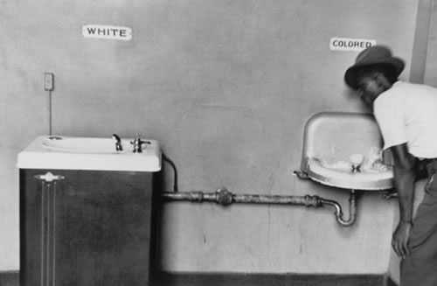
Separate drinking fountains were an example of the deliberate public discrimination against black citizens.

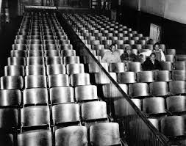
A segregated cinema in the USA 1940

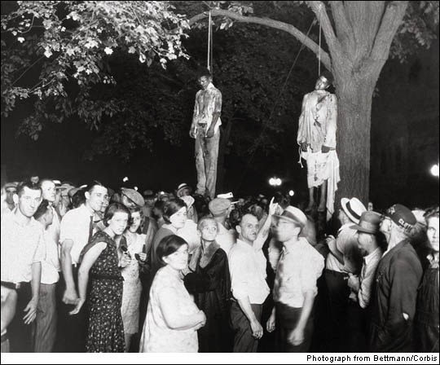
The lynching of Abram Smith and Thomas Shipp outside the jail in Marion Indiana. Lynchings were often major social events, many of which were attended by children.

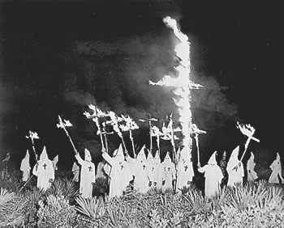
The Ku Klux Klan were involved in many of the lynchings that took place. This was a secret organisation of white Southerners who used parades, beatings and lynchings to intimidate black people, Jews, Catholics and foreign immigrants. The attacks usually took place at night and members of the Klan often left behind a burning cross as their calling card. Their aim was to keep whites in control of the Southern states.

Key People/ groups in the Civil Rights movement
Booker T Washington | Born into slavery in Virginia in the mid-to-late 1850s, Booker T. Washington put himself through school and became a teacher after the Civil War. In 1881, he founded the Tuskegee Normal and Industrial Institute in Alabama (now known as Tuskegee University), which grew immensely and focused on training African Americans in agricultural pursuits He believed by doing this they would become accepted by white Americans.
The NAACP | To ensure the political, educational, social, and economic equality of rights of all persons and to eliminate racial hatred and racial discrimination.
Elizabeth Eckford | Elizabeth Eckford was born in Little Rock in 1942. Like most children in the Deep South, Eckford went to a segregated school. On 4th September, 1957, Elizabeth Eckford and eight other African American students attempted to enter Little Rock Central High School, a school that previously had only accepted white children. The governor of Arkansas, Orval Faubus, was determined to ensure that segregation did not take place and sent the National Guard to stop the children from entering the school.
Rosa Parks | On 1st December, 1955, Rosa Parks, left Montgomery Fair, the department store where she worked, and got on the same bus as she did every night. As always she sat in the "black section" at the back of the bus. However, when the bus became full, the driver instructed Rosa to give up her seat to a white person. This had happened to Rosa several times before. In fact, the same bus driver had forced her off the bus in 1943 for committing the same offence. Once again she refused and was arrested by the police. She was found guilty of violating the segregation law and fined.
Martin Luther King | King travelled the country making speeches and inspiring people to become involved in the civil rights movement. As well as advocating non-violent student sit-ins, King also urged economic boycotts similar to the one that took place at Montgomery. He argued that as African Americans made up 10% of the population they had considerable economic power. By selective buying, they could reward companies that were sympathetic to the civil rights movement while punishing those who still segregated their workforce.
Malcolm X | Malcolm X's views and ideas became the foundation of more radical civil rights groups such as the Black Panthers, one of the movement's most violent groups. Malcolm X didn't think peaceful methods did enough to help black people.  Malcolm X called on people to use violence to demand more rights. He appealed to young people and those who lived in towns and cities.  Black Power – the use of violence to demand equal rights.
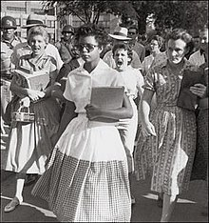
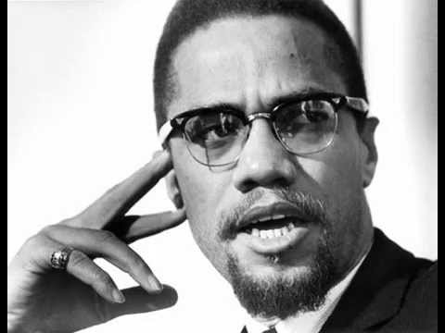

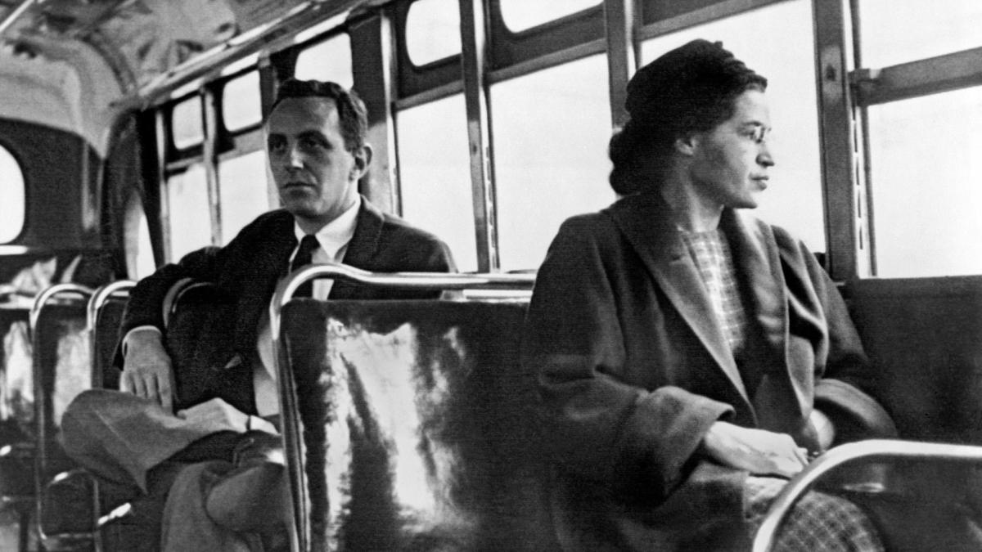
Consequences
In 1964, Martin Luther King won the Nobel Peace Prize. The third Monday in January in America is Martin Luther King Day, a national holiday.
White violence forced the US government to step in to give black people their rights:
The Civil Rights Act (1964) outlawed segregation in schools, public places and jobs.
The Voting Rights Act (1965) made it illegal to do anything that might limit the number of people able to vote. Some states had used a literacy test to try and prevent black people from voting as many black people had limited access to education.
The Fair Housing Act (1968) banned discrimination in housing.
In 2008, a black American, Barack Obama, became President of the United States.

However
Civil rights did not give black Americans prosperity or jobs. Black Americans – particularly in the 'black ghettos' in the towns – remained poor and angry.
As a result, more extreme black leaders such as Malcolm X, and more radical groups such as the Black Panthers, were set up – black protests in the 1970s became more violent.
Martin Luther King was assassinated in 1968.
Black poverty, and violence and discrimination against black people, continues.

